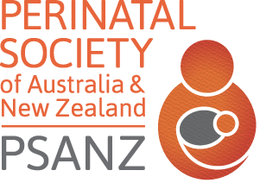
THE PERINATAL SOCIETY OF
AUSTRALIA & NEW ZEALAND
www.psanz.com.au

Eligibility for PSANZ New Investigator Award (NIA)/ECR Travel Award – 2024
SUPERVISOR APPROVAL FORM
Nominee Name:
Nominee email, Ph. # or other contact details:
Membership Discipline (Select ONE of): Discovery Science / Midwifery / Neonatal Nursing / Neonatology / Obstetrics / Perinatal / Epidemiology - Public Health / Allied Health - other
The above nominee confirms that (please check boxes to confirm):
They are a current member of PSANZ
They are the presenter AND first author of the submitted abstract
They have only nominated 1 abstract for consideration for a NIA/travel award
They will be present at the closing ceremony when the awards are announced
They do not hold a university academic appointment higher than level b, or a university adjunct appointment higher than adjunct senior research fellow or adjunct senior lecturer.
They have not been awarded a PSANZ NIA previously (only applicable to NIA applicants)
Has been performing research for less than 5 years
Is not 1st author on an abstract or publication dated prior to 2023
In addition, the nominee must be either (select A, B or C):
A. Enrolled (full- or part-time) in a research degree (Bachelor, Honours, Masters, or PhD)
Please provide:
1. Receipt for 2024 PSANZ or PSNZ membership
2. Evidence demonstrating enrolment status for 2024

B. Within 5 years of award of a Bachelor/Honours degree
Please provide:
1. Receipt for 2024 PSANZ or PSNZ membership
2. List of publications and abstracts
3. Evidence of employment level

C. Within 2 years of a postgraduate research degree (Masters, or PhD)
Please provide:
1. Receipt for 2024 PSANZ or PSNZ membership
2. Evidence of the date of award of the relevant degree

Applicant Signature Date / /
Supervisor Signature Date / /
Supervisor/ HOD Name

***Please upload completed form with online submission.

